**UNIVERSIDAD DE GUADALAJARA**

**CUCEI**

CARRERA: **INGENERIA EN COMPUTACION**

SIMULACION 2: **COMPARADOR BINARIO**

ALUMNO: **EFRAIN ROBLES PULIDO**

CODIGO: **221350095**

*NOMBRE DE LA MATERIA:* **ARQUITECTURA DE COMPUTADORAS**

*SECCIÓN:*  **D10** *CALENDARIO:* **2021B**

*NOMBRE DE LA PROFESORA:* **THELMA ISABEL MORALES RAMIREZ**



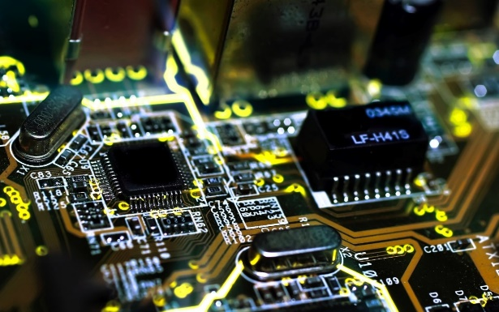

**Comparador Binario**

|  |  |  |  |  |  |  |  |
| --- | --- | --- | --- | --- | --- | --- | --- |
| **# Caso** | **A** | | **B** | | **A>B** | **A<B** | **A=B** |
| **A1** | **A0** | **B1** | **B0** | **M** | **m** | **I** |
| 0 | 0 | 0 | 0 | 0 | 0 | 0 | 1 |
| 1 | 0 | 0 | 0 | 1 | 0 | 1 | 0 |
| 2 | 0 | 0 | 1 | 0 | 0 | 1 | 0 |
| 3 | 0 | 0 | 1 | 1 | 0 | 1 | 0 |
| 4 | 0 | 1 | 0 | 0 | 1 | 0 | 0 |
| 5 | 0 | 1 | 0 | 1 | 0 | 0 | 1 |
| 6 | 0 | 1 | 1 | 0 | 0 | 1 | 0 |
| 7 | 0 | 1 | 1 | 1 | 0 | 1 | 0 |
| 8 | 1 | 0 | 0 | 0 | 1 | 0 | 0 |
| 9 | 1 | 0 | 0 | 1 | 1 | 0 | 0 |
| 10 | 1 | 0 | 1 | 0 | 0 | 0 | 1 |
| 11 | 1 | 0 | 1 | 1 | 0 | 1 | 0 |
| 12 | 1 | 1 | 0 | 0 | 1 | 0 | 0 |
| 13 | 1 | 1 | 0 | 1 | 1 | 0 | 0 |
| 14 | 1 | 1 | 1 | 0 | 1 | 0 | 0 |
| 15 | 1 | 1 | 1 | 1 | 0 | 0 | 1 |

**M**= $\left(\overline{A_{1}} A_{0} \overline{B_{1}} \overline{B_{0}}\right)+\left(A_{1} \overline{A_{0}} \overline{B_{1}} \overline{B_{0}}\right)+\left(A_{1} \overline{A_{0}} \overline{B_{1}} B_{0}\right)+\left(A_{1} A_{0} \overline{B_{1}} \overline{B_{0}}\right)+\left(A_{1} A_{0} \overline{B_{1}} B_{0}\right)+(A_{1} A_{0} B_{1} \overline{B_{0}})$

**m**= $\left(\overline{A_{1}} \overline{A_{0}} \overline{B_{1}} B_{0}\right)+\left( \overline{A_{1}} \overline{A_{0}} B_{1} \overline{B_{0}}\right)+\left(\overline{A_{1}} \overline{A_{0}} B_{1} B_{0}\right)+\left(\overline{A_{1}} A_{0} B_{1} \overline{B_{0}}\right)+\left(\overline{A_{1}} A_{0} B_{1} B_{0}\right)+(A_{1} \overline{A_{0}} B_{1} B_{0})$

**I**= $\overline{(A_{1}} \overline{A_{0}} \overline{B_{1}} \overline{B_{0}})+\left(\overline{A_{1}} A_{0} \overline{B_{1}} B_{0}\right)+\left(A_{1} \overline{A_{0}} B_{1} \overline{B_{0}}\right)+(A_{1} A_{0} B_{1} B_{0})$